**QSMART – HG CELLS REPLACEMENT**

**PROCEDURE**

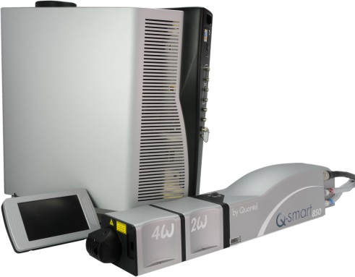

**Toolkit:**

Metric Allen keys

Cable tool RE150002

A scope

Screwdriver

**System**: QSMART

|  |  |
| --- | --- |
| **SM010361** | **Q-SMART 2ND HG CELL ASSY** |
| **SM010363** | **Q-SMART 3RD HG CELL ASSY** |
| **SM010365** | **Q-SMART 4TH HG CELL ASSY** |
| **SM010367** | **Q-SMART 5TH HG CELL ASSY** |

**Purpose**: This document details how to change the HG cells

|  |  |  |
| --- | --- | --- |
| Revision | date | modification |
| Initial issue | July 4, 2014 |  |
|  |  |  |
|  |  |  |
|  |  |  |

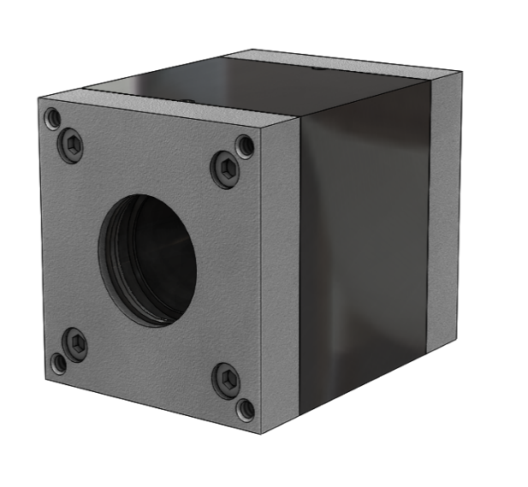

# DISSASEMBLY OF THE CELL

* Turn off the power supply
* Remove the cover of the Harmonic generator (2 M3x6 BHC) and the protective cover (3 screws M3x6 BHC).

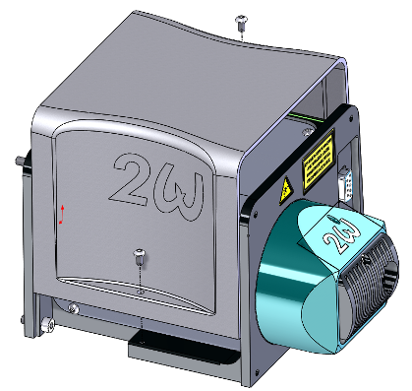 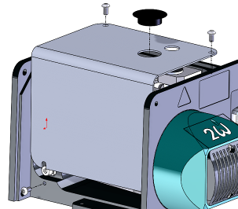

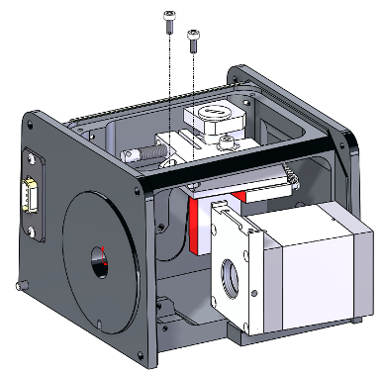

Unfasten the cell (2 screws CHC M3x8)

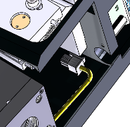

Unplug the connector from the PSHG card (J3)

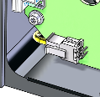

# IMPLEMENTATION OF THE CELL

|  |  |  |
| --- | --- | --- |
| 2.00 | V/CHC-M0308A4 | CHC M3X8 SCREW |
| 2.00 | V/CHC-M0408A2 | CHC M4X8 SCREW |
| 2.00 | R/ZU—D04—A2 | ZU4 WASHER |



Install the cell on the reference surface and fasten the cell with 2 screws (CHC M3x8).



Pass the connector through the hole under the cell and plug it to the PSHG card (J3)



# INTEGRATION 2W @ 532nm

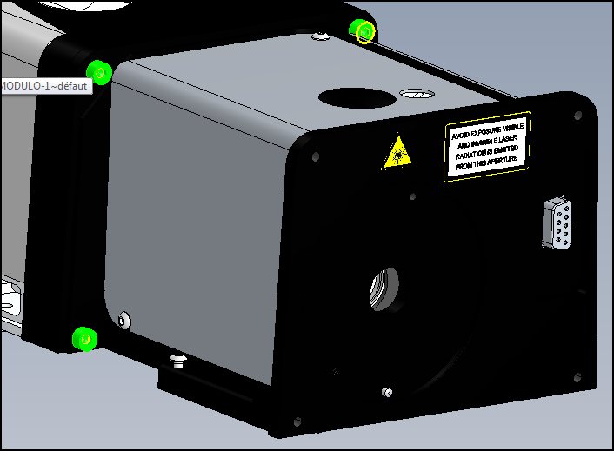

* Turn off the power supply
* Close the QSmart sevice application
* Remove the cover of the Harmonic Generator
* Connect the 2W HG and tight the 4 screws
* Place the dichroics module on the HG (2screws)
* 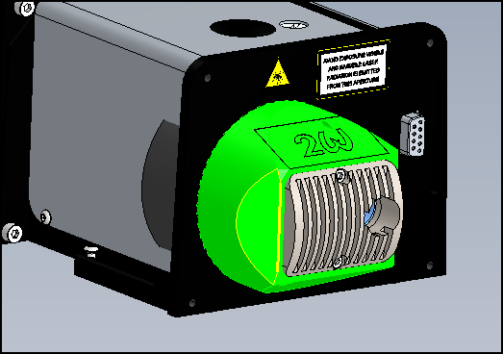
* Disconnect the QTouch and plug the ethernet cable
* Turn on the Power supply
* Launch Qsmart-Service application on your computer

Go to the tab « Harmonics »

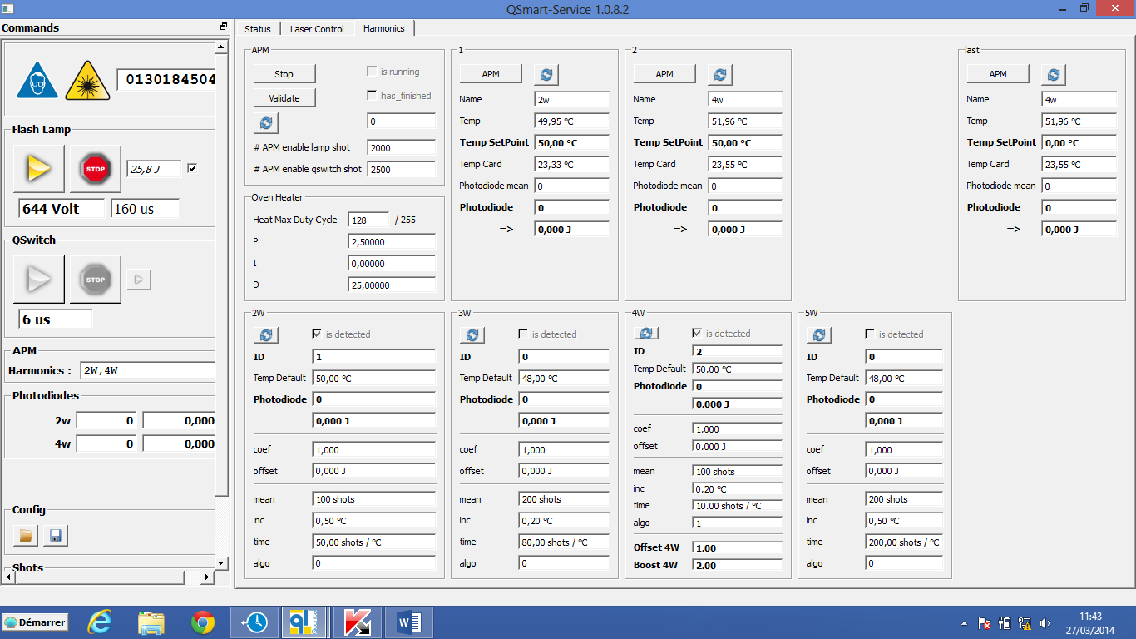

Check if :

* Application recognize the HG
* Temperature is increasing inside the cell
* Temp SetPoint is 50°C
* Remove the shield cover plate of the HG

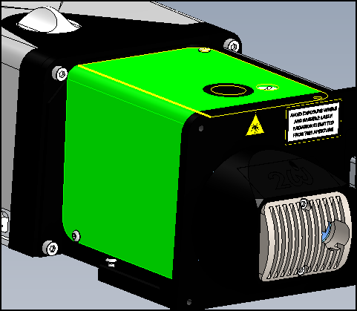

**Cell alignment of 6° TILT**

* Check the tilt of the cell

(6° around the horizontal axis 🡪the edge of both steel parts must be parallel)

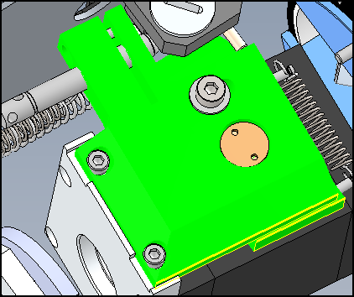

**//**

* If not, loosen the lateral rotation axis of the cell, and place an Allen key in the hole of the adjusting screw. Turn and tilt the cell until 6°.

**When done,** **don’t forget to tighten the screw on the lateral axis!**

|  |  |
| --- | --- |
|  | **6°** |

Lateral axis of the cell

Adjusting screw

**Correct starting position of the cell should be parallel with the module of the cell**

|  |  |
| --- | --- |
|  | **//** |
| Loosen the vertical rotation axis of the cell | With the adjusting screw, bring the cell to a neutral vertical position**.** |

**Phase matching of the cell**

Install powermeter at the output of the system

Active QS shots

**Be sure the srew of vertical rotation axis is loose**

When the cell has reach the temperature setting point, place an Allen key in the hole of the adjusting screw and finely adjust the angle of the cell by checking the output Energy.

Optimize the 1/4 wave plate. And tight it.

Place the shield cover plate on the cell

Wait and repeat this operation a second time…

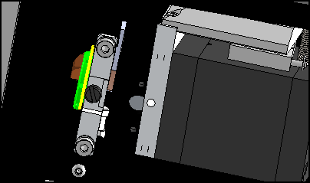

Quarter wave plate

*If the Charger SetPoint is adjusting for 850mJ in InfraRed, and the energy of 2W is more than specifications it’s ok, go to the following stage. If not, adjust the Charger SetPoint until specification is reach.*

***Be careful, don’t go further than 900mJ in the IR****.*

* Wait until the stabilization of the output Energy and finally tight the screw of vertical rotation axis cell.

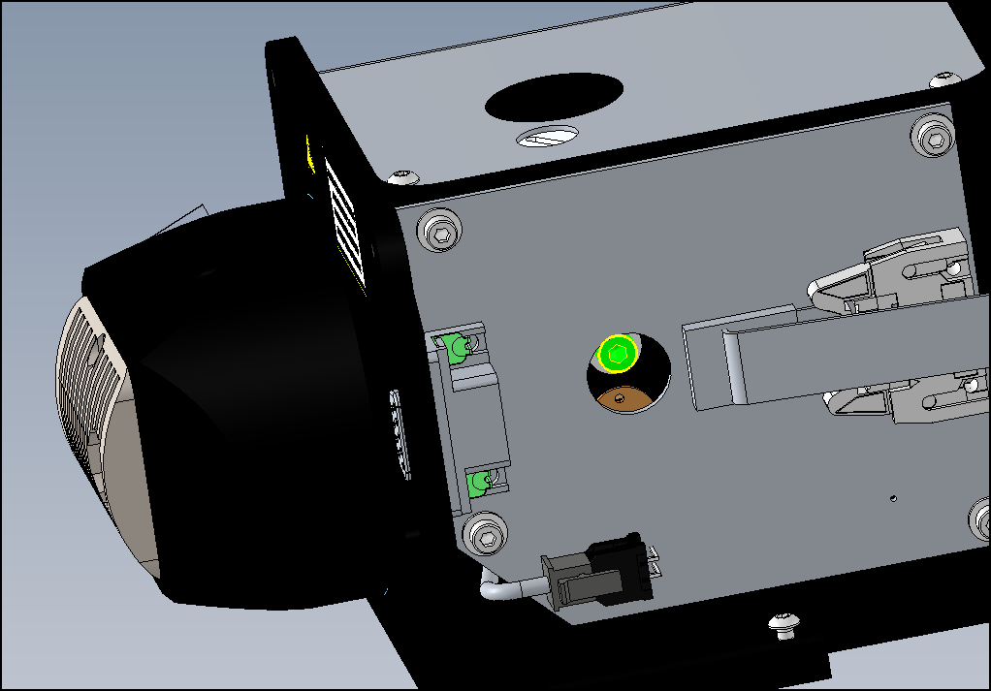

* Place the shield cover plate on the cell
* Connect the tool RE150002 between the 9pins connector at the output of the cell to a scope.
* Adjust the potentiometer of the PSHG board at the minimum value and check the signal on the scope is under 5V (not saturated)
* Adjust again the potentiometer in order to read the value of 2500 on the QSmart Service application. (Photodiode)

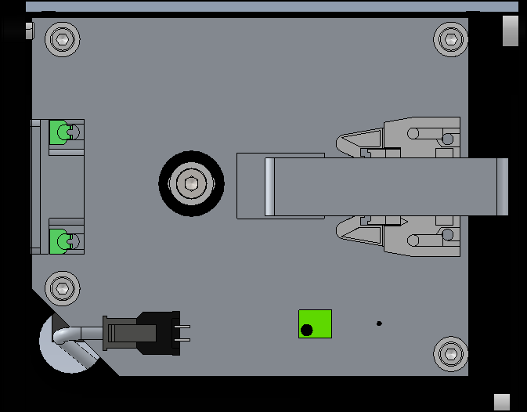

potentiometer

* Place the HG cover
* Launch APM.
* When APM is done, if the temperature of the cell is +/-1°C than nominal temperature: save the APM by a clicking on « validate » and after go to tab status: FPGM and check the new setting point TEMP1S.

If not, start again the procedure.

* Turn off and after turn on the power supply, launch QS shots.

Check if the new TempSet Point is saved and if the nominal energy of the 2W is reached before 2500 shots.

Screw the HG shield, place a warranty sticker. Place and screw the HG cover

# INTEGRATION 3W @ 355nm

* Turn off the power supply
* Remove the 2W dichroics and place it in this box
* Tight the third Harmonic Generator on the second HG
* Place the 3W dichroics at the output of the 3 HG
* Turn on the power supply
* Launch QSmart Service application
* Check if :
  + Application recognize the first and the second HG,
  + Temperature is increasing inside the two cells,
  + Temp SetPoint is 50°C for the two cells.

**a) Cell alignment of 6° TILT**

* Check the tilt of the cell is 6° around the vertical axis

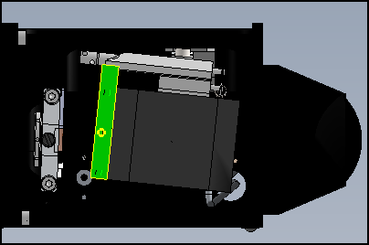

**6°**

**b) Correct starting position of the cell should be parallel with the module of the cell**

**//**

**Excentric cam**

|  |  |
| --- | --- |
|  |  |
| Loosen the horizontal axis screw of the cell.  **After :**  **be sure the mechanical excentric cam is in the middle of is range** | With the adjusting screw, bring the cell to a neutral horizontal position |

c) Phase matching of the cell

* Install powermeter at the output of the system
* Configure the temperature parameter of the 2W (that was find before).
* **Be sure the screw of horizontal axis is loose**
* Active QS shots
* When the two cells have reach their temperature setting point, place an Allen key in the hole the adjusting screw of the third harmonic and finely adjust the angle of the cell by checking the output Energy.
* Optimize the wave plate on the third harmonic cell. And tight it.

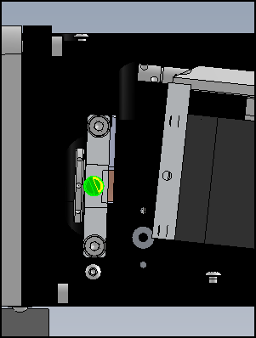

Wave plate

* Optimize again the phasematching with the adjusting screw
* Place the shield cover plate on the cell
* Wait and do this operation a second time…
* Wait until the stabilization of the output Energy and finally tight the screw of horizontal axis cell.

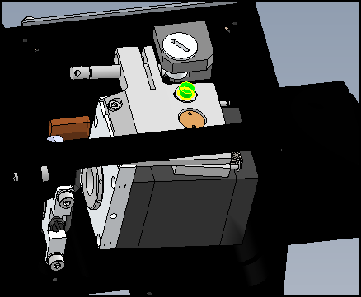

* Place the shield cover plate on the cell
* Connect the tool RE150002 between the 9pins connector at the output of the cell to a scope.
* Adjust the potentiometer of the PSHG board at the minimum value and check the signal on the scope is under 5V (not saturated)
* Adjust again the potentiometer in order to read the value of 1200 on the QSmart Service application. (potodiode)
* Place the HG cover
* Launch APM.
* When APM is done, if the temperature of the 2 cells are +/-1°C than nominal temperature: save the APM by a clicking on « validate » and after go to tab status: FPGM and check the news setting point TEMP1S and TEMP2S.
* If not, start again the procedure.
* Turn off and after, turn on the power supply, launch QS shots.
* Check if the new TempSet Point are saved and if the nominal energy of the 3W is reached before 2500 shots.
* **Remove the Cap on the shield cover plate which allow the customer to acces to the mechanical excentric came**

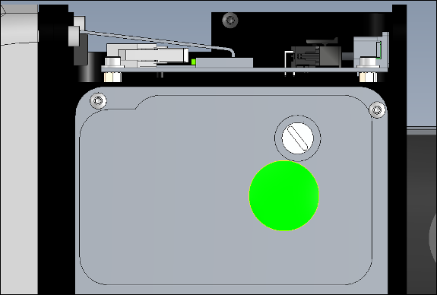

* Place the HG shield, place a warranty sticker. Place and screw the HG cover.

# INTEGRATION 4W @ 266nm

* Turn off the power supply
* Remove the 2W dichroics and place it in this box
* Tight the Four Harmonic Generator on the second HG
* Place the 4W dichroics at the output of the 4 HG
* Remove the shield cover plate
* Turn on the power supply
* Launch QSmart Service application
* Check if :
  + application recognize the first and the second HG,
  + temperature is increasing inside the two cells,
  + Temp SetPoint is 50°C for the two cells.

1. **Cell alignment of 6° TILT**

* Check the tilt of the cell is 6° around the vertical axis



**6°**

**b) Correct starting position of the cell should be parallel with the module of the cell**

|  |  |
| --- | --- |
| Excentric cam | **//** |
| Loosen the horizontal axis of the cell  **Then verify that the eccentric cam is in the middle of is range** | With the adjusting screw, bring the cell to a neutral horizontal position**.** |

c) Phase matching of the cell

Install powermeter at the output of the system

* Configure the temperature parameter of the 2W (that was find before).
* Active QS shots
* When the two cells have reach their temperature setting point, place an Allen key in the adjusting screw of the fourth harmonic and finely adjust the angle of the cell by checking the Energy.
* Change QSwitch frequency to F/10 (for this, go to the tab « status » enter the value in cmd QSPAR1=0, **QSPAR2=10**, QSPAR3=1

or

* Go to the tab « Laser Control » and change the Pattern value.

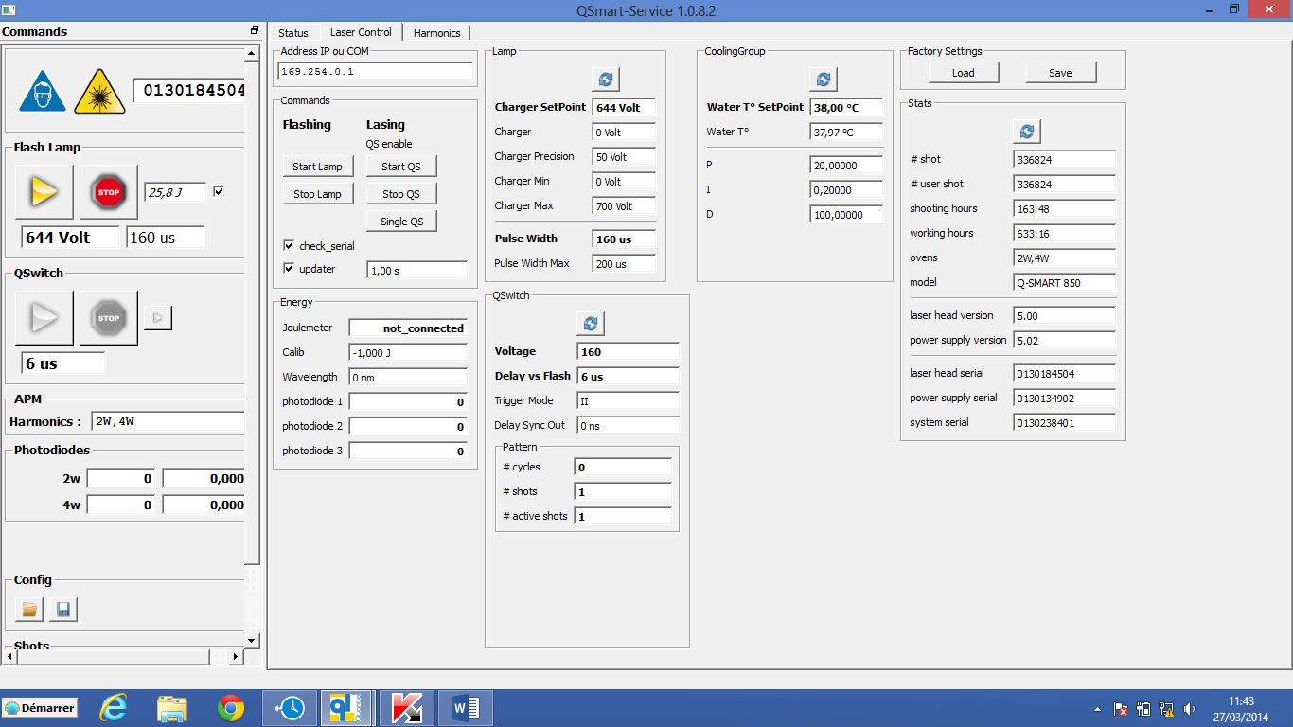

# cycles 🡪0

# shots 🡪10

# active 🡪0

* Check if we are able to find the maximum of energy at 1Hz by turning the excentric cam

Nota1 : at F/10, go step by step and take the time for crystal temperature stabilization

Nota2 : It’s just a question of identifying a maximum. For example, we could have 160mJ with F/10…

(If it’s not the case, place the Allen key inside the hole of the adjustment screw, make the phase matching like that and with the mechanical excentric cam come to the minimal position)

* Change the QSwitch frequency (QSPAR1=0, **QSPAR2=1**, QSPAR3=1) and adjust the phase matching at 10Hz with the excentric cam.
* Wait until stabilization of the cell and tight the horizontal axis of the cell.



* Place the shield cover plate cell
* Connect the tool RE150002 between the 9pins connector at the output of the cell to a scope.
* Adjust the potentiometer of the PSHG board at the minimum value and check the signal on the scope is under 5V (not saturated)
* Adjust again the potentiometer in order to read the value of 1200-2500 on the QSmart Service application. (Photodiode)
* Place the HG cover
* Launch APM.
* When APM is done, if the temperature of the 2 cells are +/-1°C than nominal temperature: save the APM by a clicking on « validate » and after go to tab status : FPGM and check the news setting point TEMP1S and TEMP2S.
* If not, start again the procedure.
* Check that the boost works:
* Stop of the QSwitch during 30s then, activate the QSwitch again. The system have to return to the same energy than after the APM.
* Stop flashlamp during 10s, then start the flashlamp and the QSwitch. The system have to return to the same energy than after the APM.
* Turn off and after, turn on the power supply, launch QS shots.
* Check if the new TempSet Point are save and if the nominal energy of the 4W is reach before 2500 shots.
* **Remove the Cap on the shield cover plate which allow the customer to acces to the excentric cam**

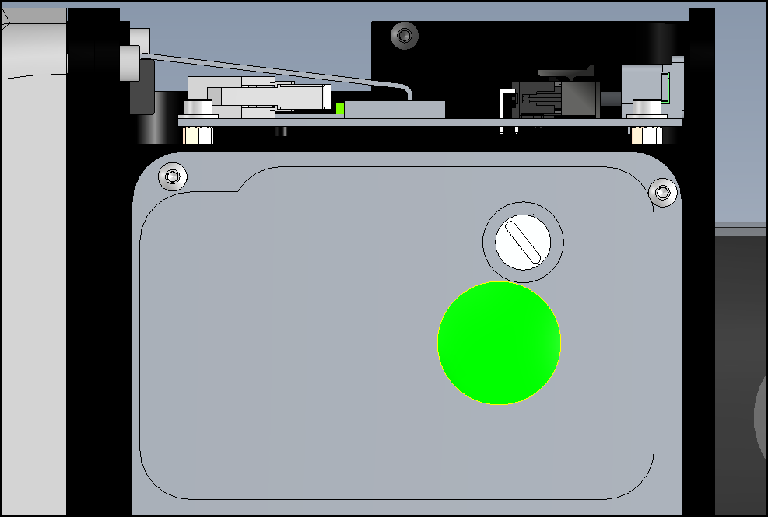

* Screw the HG shield, place a warranty sticker. Place and screw the HG cover.

# INTEGRATION 5W @ 213nm

* Turn off the power supply
* Remove the 2W dichroics and place it in this box
* Tight the fith Harmonic Generator on the fourth HG
* Place the 5W dichroics at the output of the 5 HG
* Remove the shield cover plate
* Turn on the power supply
* Launch QSmart Service application
* Check if :
  + application recognize the first and the second HG,
  + temperature is increasing inside the two cells,
  + Temp SetPoint is 50°C for the two cells.

**a) Cell alignment of 6° TILT**

* Check the tilt of the cell is 6° around the vertical axis



**6°**

**b) Correct starting position of the cell should be parallel with the module of the cell**

|  |  |
| --- | --- |
| **Exentric cam** | **//** |
| Loosen the horizontal axis screw of the cell.  **After :**  **be sure the mechanical excentric cam is in the middle of is range** | With the adjusting screw, bring the cell to a neutral horizontal position |

c) Phase matching of the cell

* Install powermeter at the output of the system
* Configure the temperature parameter of the 2W (that was find before).
* **Be sure the screw of horizontal axis is loose**
* Active QS shots
* When the two cells have reach their temperature setting point, place an Allen key in the hole the adjusting screw of the third harmonic and finely adjust the angle of the cell by checking the output Energy.
* Optimize the wave plate on the third harmonic cell. And tight it.



Wave plate

* Optimize again the phasematching with the adjusting screw
* Place the shield cover plate on the cell
* Wait and do this operation a second time…
* Wait until the stabilization of the output Energy and finally tight the screw of horizontal axis cell.



* Place the shield cover plate on the cell
* Connect the tool RE150002 between the 9pins connector at the output of the cell to a scope.
* Adjust the potentiometer of the PSHG board at the minimum value and check the signal on the scope is under 5V (not saturated)
* Adjust again the potentiometer in order to read the value of 1200 on the QSmart Service application. (potodiode)
* Place the HG cover
* Launch APM.
* When APM is done, if the temperature of the 2 cells are +/-1°C than nominal temperature: save the APM by a clicking on « validate » and after go to tab status: FPGM and check the news setting point TEMP1S and TEMP2S.
* If not, start again the procedure.
* Turn off, then turn on the power supply and launch QS shots.
* Check if the new TempSet Point are saved and if the nominal energy of the 5W is reached before 2500 shots.
* **Remove the Cap on the shield cover plate which allow the customer to acces to the mechanical excentric came**



* Place the HG shield, place a warranty sticker. Place and screw of the HG cover.